How to create bottom-referenced dataset and analysis:

Below the steps are outlined to make a bottom-referenced data set and analysis, which follows very closely to surface-referenced data sets.

1. First a new data set must be created, almost always by replicated the parameters from the primary data set, but instead of surface referenced it must be bottom-referenced. The easiest way to do this is to use the **REPLICATE_DATASET** procedure in macebase2:

* Open SQL developer
* Go to Macebase2/Procedures/REPLICATE_DATASET & populate inputs (edit the Input Value column). Choose the ship, survey, data set ID that you want to replicate and the number for the new data set. Fill in the other meta data (name, owner, description), and select 0 for ‘copy_all_data’. Choosing 0 will simply create the structure for the data set and not fill in the integration data, since we want to do that manually by exporting the EV files again, but this time bottom-referenced.

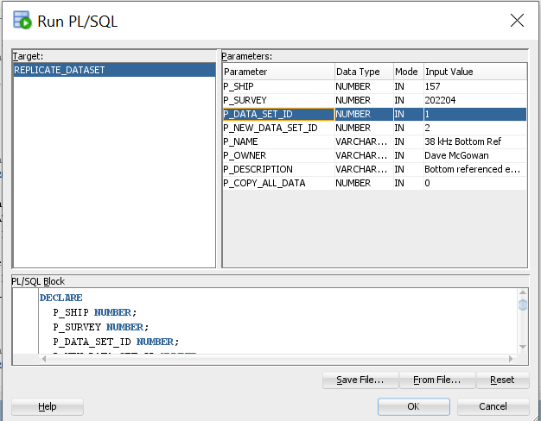

1. Go to the macebase 2 **DATA_SETS table**: Macebase2/Tables/DATA_SETS and find the newly created entry (row) with the data set number chosen in the previous step under new_data_set_id (in the example snapshot, it would be data set 2).

* Find the ‘LAYER_REFERENCE’ column and edit the entry to be ‘Bottom’
* Find the ‘LAYER_REFERENCE_NAME’ column and edit the entry to be ‘bottom_exclusion’. You could choose any line to reference from, but this is our standard MACE survey bottom line.
* Once the edits have been made, click the icon with a green check mark at the top to commit the changes to the database.

1. Now, you’ll need to fill the database with the integration data like a normal surface-referenced data set

* Open MACE MasterApp and the **Exporter**. Select the survey, ship and new bottom-referenced data set ID. On the second tab, you should not need to edit anything, but it is always good to check that it looks the way you expect. The layer reference and name should be ‘Bottom’ and ‘bottom_exclusion’ and the layer reference offset should be equal to the offset of the bottom exclusion line to the true bottom. Generally, this will be -0.5 m for all surveys except for the EBS, where it is currently -0.25 m. On the first tab, export the EV files to your new bottom-referenced export folder.
* From the MasterApp, again open the macebase2 **Loader**, point it to the newly exported files and load into the new data set ID.

1. Finally, you will need to copy over the parameters for the primary analysis and link it to the primary analysis (typically the main, surface-referenced).

* Open up **MacebaseAnalysis** from the Masterapp and select the option to ‘Create a new analysis’. Create a new analysis using the bottom-referenced data set that’s linked to primary analysis. It will look similar to the following:

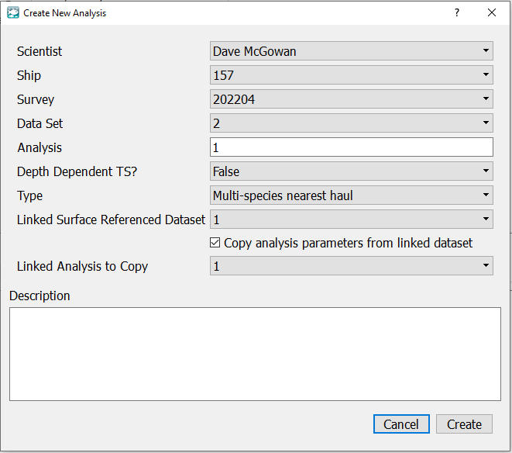

1. Run the newly created analysis.

See Mike, Nate or Rick with questions.